# Hunt Statement

**The Continuing Struggles of the Hungry UWB Students on Campus**

Develop an understanding for what students at University of Washington Bothell (UWB) want from local food options, and what they as consumers find to be a struggle in their quest for food. The goal of this research is to better deliver services to consumers to drive increased economic prosperity for the University of Washington, Bothell, and local business owners in general.

Will sample key student populations on the UWB campus who continue to struggle with the balance of getting nutritional, filling meals and finding an eatery that fits within their budget. Will conduct interviews to collect details about their experiences and schedules on campus. Will model their schedules and activities on the UWB campus and highlight how technology may address key needs in their search for food while on campus.

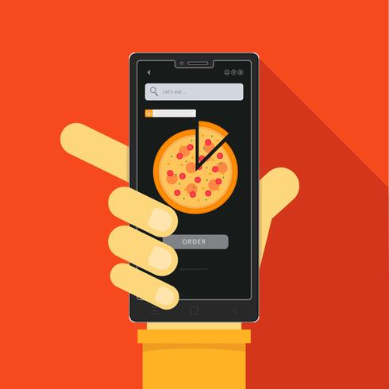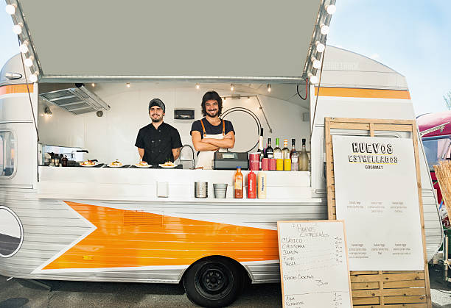

# Plan for Generative Research

* Compile observations taken from ethnographic surveys and derive meaningful user requirement ‘candidates’ to pursue.
* Perform preliminary interviews to gather user requirements, define problems within existing solutions, and gather realistic data on steps students take when searching for food options in campus. Use the preliminary interviews to gather some pain points and opportunities for improvement.
* Compose a questionnaire to gauge general user base preferences and reactions towards the product idea.
  + Are people willing to download/use another food app?
  + How many times do people purchase food on campus a week?
  + How many food options do they currently know of near campus?
* After generating system requirements, follow with a second survey to gather user preferences for application design
  + Map view, list view, both?
  + Optional account or mandatory account?
  + Anonymous reviews or tagged reviews?

# Preliminary Interview Questions

* How often do you get food on campus (per week)?
* What are the methods you currently use to find local food options? (Websites, applications, etc.)
  + What do you like about the primary method you answered for the question above?
  + What do you dislike about the primary method you answered for the question above?
  + What does your current primary method lack in finding food (if any)?
* What makes you decide what food to get on campus?
* What do you think of the Campus Food Truck Program?
* What’s the most difficult or frustrating part of finding food on campus?
* Are food allergies or sensitivities important to you?
* What are some of the common concerns you have, if any, when you place mobile food orders through other applications? (Security, miscommunication, etc)
* What are your current solutions for when you don’t have enough time for food while on campus?
* What kind of tools would you find helpful for finding local food?
* What would need to be provided for you to use a different method than your current method?
* What are some features you would want in an application that helps you find food around campus?
* What kind of food would you like to see come to the campus?
* What could UW Bothell do to help you eat more on campus?